

**Safeguarding Children Training**

**Groups 1 & 2**

**What you need to know**

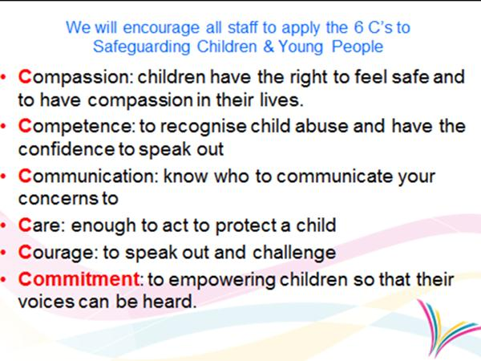

**Group 1 & 2 Safeguarding Children training (written information)**

**Group 1 Candidates:** All new staff, Board level Executives and Non-Executives, Lay members, receptionists, administrative staff, caterers, domestics, transport, porters, community pharmacist counter staff and maintenance staff, including those non-clinical staff working for independent contractors within the NHS such as GPs, optometrists, contact lens and dispensing opticians, dentists and pharmacists, as well as volunteers across health care settings and service provision.

**Group 2 Candidates:** All non-clinical and clinical staff that

have any contact with children, young people and/or parents/carer’s. This includes administrators for looked after children and safeguarding teams, health care students, clinical laboratory staff, phlebotomists, pharmacists, ambulance staff, orthodontists, dentists, dental care professionals, audiologists, optometrists, contact lens and dispensing opticians, adult physicians, surgeons, anesthetist’s, radiologists, nurses working in adult acute/community services (including practice nurses), allied health care practitioners and all other adult orientated secondary care health care professionals/ workers, including technicians.

Reference: Safeguarding Children and Young People: roles and competencies for health care staff: Intercollegiate Document (March 2014)

This written information will be given to staff every 3 years (where these staff members are unable to complete the eLearning Module). The staff member’s Manager will be responsible for ensuring the staff member is given this written information pack and that the staff member signs the signature sheet to say they have received, read and understood the information. The completed signature sheets must be photocopied (one copy must be kept by the ward manager and the other copy must be sent FAO HR Training in the ED&TC so that the staff member’s ESR record can be updated). It is very important that this process is completed to ensure the monthly Safeguarding Children Training Compliance reports are correct.

**Core Induction:** All new staff will receive this information at core induction.

**Groups 1& 2:** Staff must complete this training every 3 years.

**Group 3:** Staff must complete face to face training within 3 months of commencing employment and then again every year. (For further details d/w your Manager or the CoCH Safeguarding Children Team ext 5596)

|  |  |
| --- | --- |
| Safeguarding Children | **Child protection and Safeguarding** is everyone’s responsibility: it is not only childcare workers that have a duty to promote the welfare of children and protect them from harm. |

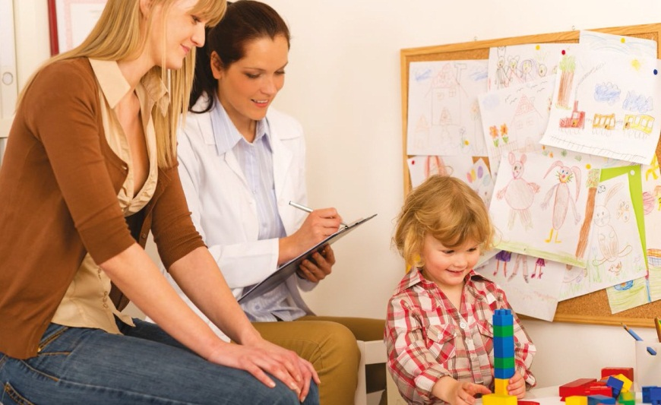When you come into contact with

children in any way in your day to day

work it is part of your job to make

sure that their wellbeing is

safeguarded.

Please note the

term ‘child/children’ means anyone who

has not yet reached their 18th birthday.

|  |
| --- |
| **Child Protection and Safeguarding**  Safeguarding is preventative and involves promoting the welfare of children by protecting them from harm and recognising the risks to their safety and security.  Child protection is the activity of protecting children who are suffering or may be likely to suffer from significant harm as a result of abuse or neglect. |

**What is child abuse?**

Child abuse is any wrongdoing that causes, or is able to cause, significant emotional or physical harm to a child. The following signs, symptoms and behaviours or indicators to not necessarily mean that a child is being abused but may mean that you have a reason to be concerned.

|  |  |
| --- | --- |
| **Physical abuse** |  |
| Physical abuse is the physical ill treatment of a child which may or may not result in an injury.  Physical abuse may involve hitting, shaking, throwing, poisoning, burning or scalding, drowning, suffocating or otherwise causing physical harm to a child. Withholding of care may also be seen to be physical abuse.  Physical abuse may also be caused when a parent/relative or carer feigns the symptoms of ill health or deliberately causes ill health to a child whom they are looking after, this is sometimes called fabricating or inducing illness. | |

|  |  |
| --- | --- |
| **Sexual abuse** |  |
| Sexual abuse of a child involves forcing or enticing a child or young person to participate in sexual activities, including prostitution whether or not the child is aware of what is happening.  Sexual abuse includes physical contact, including penetrative e.g. rape, buggery or oral sex or non-penetrative acts such as rubbing & touching outside of clothing.  Non-contact activities, such as involving children in looking at or in the producing of, sexual images, watching sexual activities, encouraging children to behave in sexually inappropriate ways, or grooming a child in preparation for abuse (including via the internet) sexual abuse is not solely perpetrated by males, women can also commit acts of sexual abuse, as can children. | |

|  |  |
| --- | --- |
| **Emotional abuse** |  |
| Emotional abuse is the persistent emotional ill treatment of a child so as to cause severe and persistent adverse effects on the child’s development.  Emotional abuse can involve: conveying an opinion that the child is worthless or unloved, valuable only in so much as they meet the needs of another person.  Age or developmentally inappropriate expectations being imposed on a child, including overprotection and limitation of exploration and learning or preventing the child from participating in normal social interactions.  It may involve serious bullying causing them to feel frequently frightened or in danger, or the exploitation or corruption of a child.  It may involve seeing or hearing the ill treatment of another (witnessing domestic abuse).  Some level of emotional abuse is involved in all types of ill treatment of a child, though it may occur alone. | |

|  |  |
| --- | --- |
| **Neglect** |  |
| Neglect is the persistent failure to meet a child’s physical and psychological needs likely to result in the serious impairment of the child’s health or development.  Neglect can occur during pregnancy for example as a result of maternal substance misuse, once a child is born, neglect may involve a parent or carer failing to:   * provide adequate food, shelter and clothing (including exclusion from home or abandonment) * protect from physical and emotional harm or danger * ensure access to appropriate medical care or treatment, failure to follow prescribed treatment/therapy plans. * ensure adequate supervision (including the use of inadequate care-givers).   Neglect may also include neglect of, or unresponsiveness to, a child’s basic emotional needs. | |

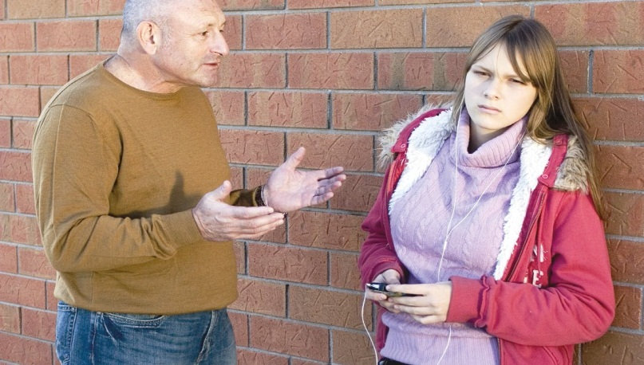

|  |
| --- |
| **Exploitation**  Exploitation means taking advantage of someone’s vulnerability to treat them badly for the abuser’s benefit. |

|  |  |
| --- | --- |
| **Child Sexual Exploitation (CSE)** |  |
| Sexual exploitation can take many forms from the seemingly consensual relationship where sex is exchanged for attention/affection, accommodation or gifts, to serious organised crime and child trafficking. What marks out exploitation is an imbalance of power within the relationship. The perpetrator always holds some kind of power over the victim, increasing the dependence of the victim as the exploitative relationship develops. | |

|  |  |
| --- | --- |
| **Child trafficking** |  |
| This means recruiting, moving or receiving a child through force, trickery or intimidation to take advantage of them. Signs and symptoms could be a **domineering** adult accompanying the child all the time and speaking for them. The child could appear withdrawn, compliant and unkempt, or show little or no use of the English language. | |

|  |
| --- |
| **Domineering**  This term means to use power, influence and/or authority over others. |

|  |  |
| --- | --- |
| **Female Genital Mutilation (FGM)** |  |
| FGM means to remove, constrict or otherwise disfigure a girl’s labia or clitoris for non-medical reasons, in most cases before they reach the age of 8. Some communities may use religious, social and cultural reasons to justify FGM, but it is a form of abuse. Signs and symptoms could range from severe pain and bleeding and chronic infections to psychological, mental health and sexual problems or damage to the reproductive system and infertility. You need to be aware | |

|  |  |
| --- | --- |
| **Radicalisation** |  |
| This is where children and young people are taught extreme, often violent, ideas based on political, social or religious beliefs. Signs of exposure to radicalisation could be behaviour changes, changes in the way they speak with others or having anew circle of friends, use of extremist terminology, reading material or messages. | |

All forms of abuse are likely to create a change in behaviour of the victim. Behaviour changes could mean a child becomes withdrawn, timid, easily startled or maybe boisterous, aggressive, attention-seeking or wanting to please. Depression, anxiety, self-harm, eating disorders and going back to younger behaviour are other possible indicators. You might also get concerned if a child is not attending school regularly or is being admitted to several different A&E departments or GP drop-in centres. These could be ways for the abuser to cover up how often the child needs medical help. It is important to know that not all children will display the same symptoms and that usually there is more than one type of abuse happening for example, physical and emotional abuse.

**What is Domestic Abuse?**

|  |  |
| --- | --- |
| **Domestic Abuse** |  |
| Any incident or pattern of incidents of controlling, coercive of threatening behaviour, violence or abuse between those aged 16 or over who are or have intimate partners of family members regardless of gender or sexuality. This can encompass but is not limited to the following types of abuse:  Psychological  Physical  Sexual  Financial  Emotional  Controlling behaviour is: a range of acts designed to make a person subordinate and/or dependent by isolating them from sources of support, exploiting their resources and capacities for personal gain, depriving them of the means needed for independence, resistance and escape and regulating their everyday behaviour.  Coercive behaviour is: an act of a pattern of acts of assault, threats, humiliation an d intimidation or other abuse that is used to harm, punish or frighten their victim.  This definition, which is not a legal definition, includes so called “honour” based violence, Female Genital Mutilation (FGM) and forced marriage, and is clear that victims are not confined to one gender or ethnic group. | |

It is vital that all CoCH staff should adhere to the Trust’s Domestic Abuse Policy if a patient to whom they are giving care discloses or is suspected as being a victim of domestic abuse the need to complete a domestic abuse risk assessment ( see DA policy must be considered). The CoCH Independent Domestic Violence Advisor (IDVA) can be contacted to discuss each case in more detail ext 5596.When dealing with domestic abuse, staff must be mindful of safety issues (and that victims are at the greatest risk from the alleged perpetrator when starting to disclose the DA) therefore staff should ensure a safe and private environment to discuss further. Such discussions should only take place if the service user is alone and never in front of the alleged perpetrator. Nothing should be written regarding discussions about domestic abuse in paperwork the service user will take home from the CoCH

**The impact of a parent’s/carer’s physical and mental health, Substance misuse or Domestic Abuse on child wellbeing**

To grow up happy and safe, children need parents or carers who love, and are able to protect and care for them in a stable, safe and secure home. Physical care and daily routines are important for development so anything that upsets routines can be unhelpful. If a parent or carer’s physical or mental health is impaired because of mental ill health, substance misuse or domestic abuse, this could impair their ability to care safely and effectively for their children.



Examples of possible harm are:

* A parent/carer with mental health issues might feel unable to build attachments with their child, possibly causing emotional harm; or the child might be forced into decision making that they are not ready for.
* A child with a parent/carer who is blind or deaf may be at increased risk of physical harm as they might not be fully able to judge dangerous situations.

Seeing or hearing acts of domestic violence can have a similar effect on children as being emotionally abused. Apart from a feeling of helplessness, they may not feel safe. Research suggests that there is a high likelihood that aggression could turn towards children present. It also suggests that the stress of experiencing violence at home can impair the brain development of babies. Domestic violence is a risk to the child’s physical, emotional and social development.

**Children’s rights**

As a worker, you have a duty to make sure the rights of all individuals are promoted and that includes children’s rights. You may not directly care for or support children or young people but through your work you may come into contact with them. It is important that you understand their rights.

The Human Rights Act 1998 gives a number of fundamental rights to every person living in the UK. Some of these rights include:



* The right to life
* Freedom from torture or degrading

treatment

* The right to education
* The right to liberty and security
* Protection from discrimination

The United Nations Convention on the Rights

of the Child (UNCRC) is a worldwide agreement

between countries as to the basic rights that

children under 18 should have.

[www.unicerf.org.uk/UNICEFs-Work/UN-Convention/](http://www.unicerf.org.uk/UNICEFs-Work/UN-Convention/)

Some of the rights relating to child protection are:

* The right to life
* The right to live a health life
* The right to not be separated from their parents unless they are at risk of harm
* The right of protection from drugs, sexual abuse or any harm to their development.

Article 39 specifies that children who have been neglected or abused should receive specialist support to restore their self-respect such as counselling.

If you have any safeguarding concerns about a child or young person that you come into contact with during your work at the CoCH, or if you are concerned that an adult patients situation could impact negatively on their children/ place their children at risk, please contact the CoCH Safeguarding Children Team ext 5596, mobile 07789926177, Bleep 2395. If it is out of hours and the situation can- not wait please call the Children’s Social Care Emergency Out of Hours Duty Team on 01244 977277.

AED, Children’s Unit and Maternity Staff please follow the established Safeguarding Children Notification process’s for your clinical areas.

Also see attached flowchart.

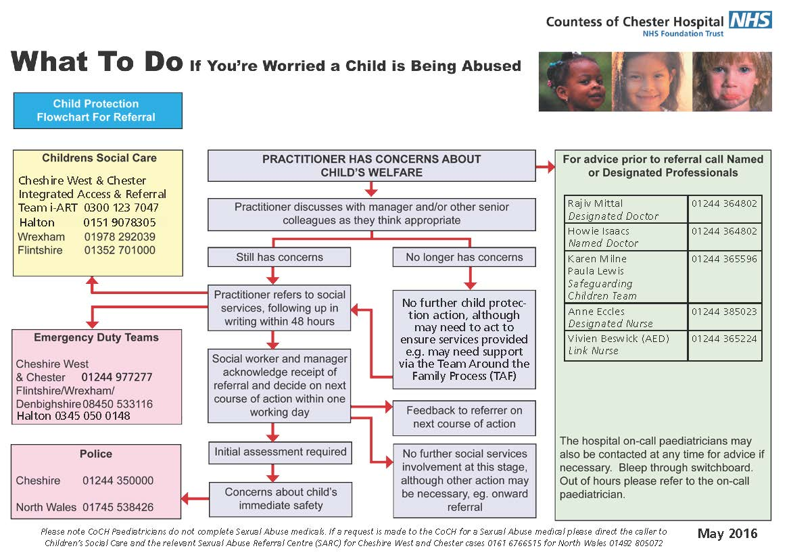

**Actions to take when concerns of suspected or alleged abuse have been made**

A child might tell someone that they have been abused or a family member, friend, worker or someone else might make an **allegation** about abuse happening at the time or in the past. Policies and procedures will give information on signs and symptoms of abuse, how to respond to the victim, lines of reporting and important telephone numbers so that any worker can feel confident when dealing with an incident. Do not hesitate if you have any concerns about a child being abused. It is not your role to judge situations, that is the responsibility of the CoCH Safeguarding Children Team, Children’s Social Care and the Police, but if you don’t alert them, they cannot act.

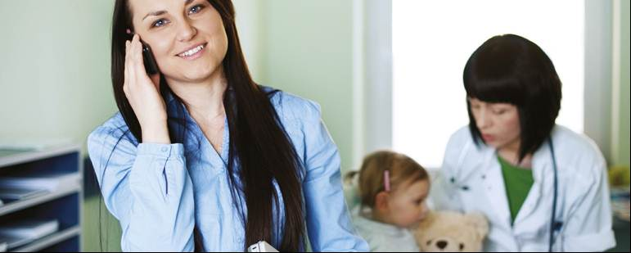

|  |
| --- |
| **Allegation**  Making an allegation means stating that someone has done something. Allegations need to be reported and investigated so it is important that you are not judgemental, but be open and honest with regard to your responsibilities. |

**The risks associated with the internet and online social networking**



The internet, with its endless access to

information, is a valuable tool but also

a potential risk to safety and security.

It is important to monitor or be aware of

what a child sees and shares, or could

become exposed to. There is a high risk

of being exposed to sexual predators (for

example, in chatrooms), pornography or

radicalisation. Using e-technology to bully

people has become an increasing problem

in recent years with over a third of young

people having been affected at least once. There has been a massive increase in online bullying due to the use of social media such as Twitter and Facebook, which is easily accessible through mobile devices as well as computers. Examples include posting negative comments on someone’s Facebook site, taking on someone’s identity on the web to humiliate them or harassing someone via their mobile phone.

**Legislation and safeguarding**

When considering the welfare of children there are several pieces of **legislation** that should be taken into account as well as your own organisation’s policies and procedures and ways of working.

CoCH policies in place

Local Safeguarding Children Board (Cheshire West & Cheshire) Manual of procedures

All Wales Safeguarding Children Procedures

CoCH Safeguarding & Promoting the Welfare of Children Policy

CoCH Safeguarding Children Clinical Supervision Policy

CoCH Domestic Abuse Policy

Staff should be aware that as with all CoCH policies, the above are all available to read via the hospital’s Intranet and SharePoint.

|  |
| --- |
| **Legislation**  The term used to describe laws and the process of creating statutory guidance on the legal rules that affect people in society. |

**The Children Act 1989:** Legislation written to protect the welfare of children who are at risk and also children who may be in need of services. This tells you exactly what you need to do it you suspect a child or young person is at risk of harm or in need of support.

[www.legislation.gov.uk/ukpga/1989/41/contents](http://www.legislation.gov.uk/ukpga/1989/41/contents)

**The Children Act 2004**: This act covers services that children and young people may access. It places a duty on Local Authorities and their partners to co-operate and make sure that services work together to safeguard children. [www.legislation.gov.uk/ukpga/2004/31/contents](http://www.legislation.gov.uk/ukpga/2004/31/contents)

**The Sexual Offences Act 2003:** This act has two parts, the first one stating what is considered a sexual offence, including physical and non-physical contact. The Act also defines sexual offences against children under 13 and under 16. The age of consent is set at 16, unless you hold a position of trust in relation to the young person, for example as their worker, teacher, trainer etc. In that case the age of consent is 18. The second part of the act deals with the sex offenders register and civil protective order.

[www.legislation.gov.uk/ukpga/2003/42/contents](http://www.legislation.gov.uk/ukpga/2003/42/contents)

**The Care Act 2014** brings care and support legislation together into a single act with new wellbeing principles at its heart. Although the Care Act is meant for adults in need of support and their carers it also makes some provisions for children and young carers. Children who care for their parents in their own home are being made part of their parent’s needs assessment in order to establish the support and help they need.

**The Children and Families Act 2014** aims to provide young carers with the same help and support as adult carers. All carers under the age of 18 have the right to have their support needs assessed and Local Authorities will help them caring for a family members as best as they can.

**Statutory Responsibility**

The Children Act 2004 (section 11) places a duty in law on this organisation to ensure that all duties are discharged with a regard to the need to safeguard children and young people. As a result of the Children Act 2004, the Trust is a statutory partner of the Local Safeguarding Children Board (LSCB). The LSCB has overall responsibility for monitoring the safeguarding children activities of this organisation. As a result the Trust must ensure that all of its employees regardless of their area of work, and regardless of whether they have regular contact with children or not, is aware of what is meant by safeguarding children and young people, and who to contact in the Trust if they are concerned about a child.

**Cheshire West & Chester Local Safeguarding Children’s Board (LSCB)**

Set up under section 13 of the Children Act 2004.

To co-ordinate and ensure the effectiveness of work that is done in safeguarding and promoting the welfare of children and young people under the age of 18.

The key priorities are to:

* support parents, carers and families in providing safe and stable homes for children and young people
* children must be safe from: maltreatment, neglect, violence and sexual exploitation, accidental injury and death, bullying and discrimination, crime and anti-social behaviour in and out of school

2004 Children Act section 11 “Duty to Co-operate”. The CoCH has a duty in law, and therefore you as a member of CoCH staff have a duty in law to always act to protect and safeguard children and young people when you have contact in your daily working at the CoCH.

The regular LSCB newsletter is sent to all CoCH Managers and is placed on the Safeguarding noticeboards in your ward/clinical area.

**What are the levels of intervention/support available to children and families in Cheshire West and Chester**

**Team Around Family (TAF)**

Team Around Family processes are initiated where a child is felt to have need of additional support from one or more agencies to enable them to have improved outcomes in terms of their health, development and achievement. TAF is a model for early intervention and support to be offered to the child and family, and health professionals may become involved if they are working with children who it is felt would benefit from TAF. **TAF is not an appropriate intervention where children are identified as having suffered from, or are at risk of suffering from, “significant harm”. Children in these circumstances should always be discussed with the CoCH Safeguarding Children Team ext. 5596 or , if not available, with Children’s Social Care in the in the area in which the child lies and/or the on-call Consultant Paediatrician.**

If a CoCH staff member, supported by the CoCH Safeguarding Children Team makes a referral to Children’s Social Care, there are two categories under which the Local Authority Children’s Social Care will assess the needs of a child

A **“child in need”** – “a child shall be taken to be in need if he is unlikely to achieve or maintain, or to have the opportunity of achieving or maintaining, a reasonable standard of health or development without the provision for him of services by the Local Authority” (Children Act 1989 section 17).

A **“Child in need of Protection”** - “a child who is suffering, or is likely to suffer significant harm, this can be a result of a deliberate act/acts or as a result of a failure to provide proper care” (Children Act 1989 section 47)

**Confidentiality/Information Sharing**

No staff member must allow their duty to patient confidentiality prevent them from sharing their concerns about a child. It is a case of sharing the appropriate information with the appropriate person or agency and about sharing that information safely.

The Data Protection Act 1998 is not a barrier to sharing information but provides a framework to ensure that personal information is shared appropriately.

Your failure to share could put a child at risk of harm.

**Please contact a member of the CoCH Safeguarding Children Team if at any time you have a safeguarding children concern and are not sure if or what information you should be sharing and with whom.**

**You must ensure all safeguarding children concerns and actions taken are clearly documented.**

**You must ensure you regularly look at the Safeguarding Notice Board in your clinical / working area to see all recent safeguarding updates and training information.**

**July 2018**